REWDT Grants Scheme

Funding generated from our community turbine enables us to award grants to community groups and individuals in accordance with our Charitable Aims.

We approved 230 applications from 94 households across Rousay, Egilsay and Wyre this year, resulting in a total of £91,635 being awarded to community groups and individuals between 1st April 2024 and 31st March 2025.

The Winter Fuel Grant helped 74 households this year, with a total of £21,300 distributed to our community members to help them directly with high energy bills. The expansion of the Well-being Grant enabled 92 residents to access well-being events and activities on REW and further afield, with a total of £18,400 being awarded to our community members, and we are proud to have been able to support our residents to access these.

Supporting community initiatives remained a priority this year. Through the allocation of our Community Group Activity Grants and General Grants, we proudly supported groups and individuals to organise and host various community events and activities throughout the year.

**Total number of grants awarded**

**230**

**Total amount of grants awarded**

**£91,635**

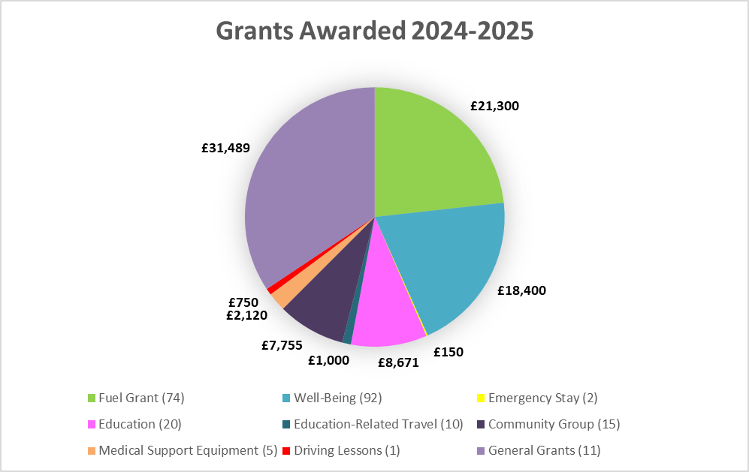

This report does not include details of unused or returned funds

**15 Community Group Activity Grants**

**Awarded to 11 Groups**

Grant funding of up to £1,000 per group, per year (maximum of 2 applications per group, per year), to support community groups in their activities and events

**Rousay Ladies Sports (2 grants) (£1,000)**

Funding towards equipment/group trip costs

**The Crafthub SCIO (1 grant) (£1,000)**

Funding towards running costs, to run multiple events throughout the year

**Rousay Traditional Dance (1 grant) (£255)**

Funding dance lessons for residents

**Rousay Parent Council (1 grant) (£500)**

Funding resources to run events and activities

**Rousay Triangle Club (1 grant) (£500)**

Funding towards group trip costs

**1st Rousay Rainbows, Brownies & Guides (2 grants) (£1,000)**

Funding resources to run activities

**Rousay Community Association (2 grants) (£1,000)**

Funding towards band costs of Harvest Home & Burns Supper

**Rousay School Fundraising Team (1 grant) (£500)**

Funding resource costs for Quiz night and tea towel printing

**Rousay Sailing Club (2 grants) (£1,000)**

Funding towards running costs and community event costs

**Rousay Poker Club (1 grant) (£500)**

Funding Poker Tournament transport costs

**Rousay School Garden Project (1 grant) (£500)**

Funding project costs

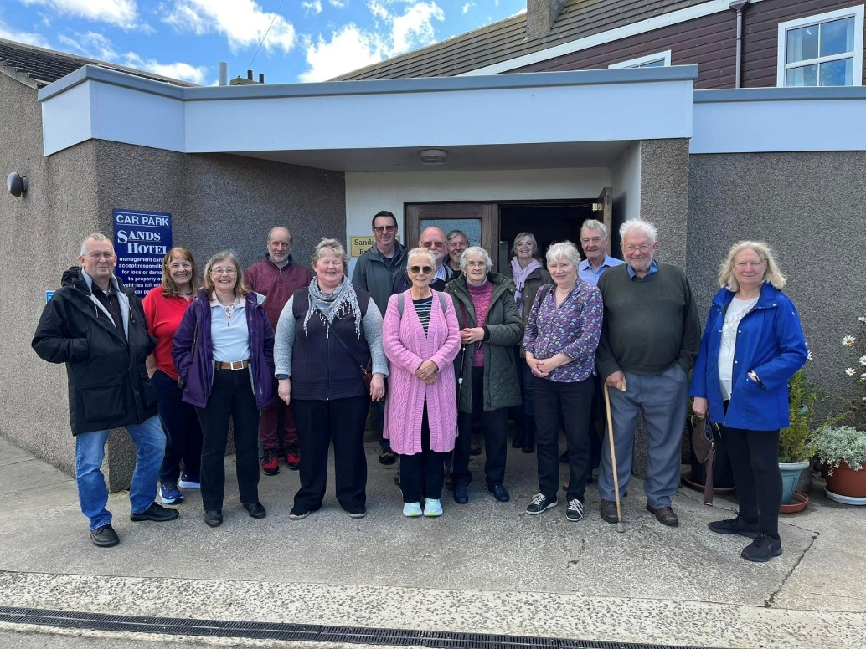

*Rousay Triangle Club’s trip to the Fossil Centre & Sands Hotel*

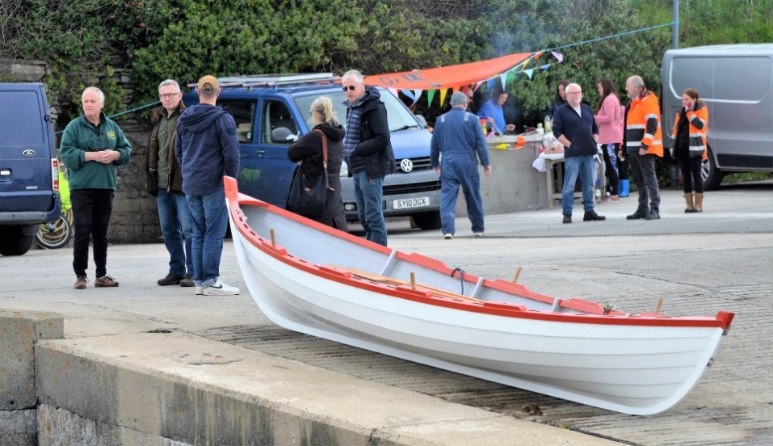 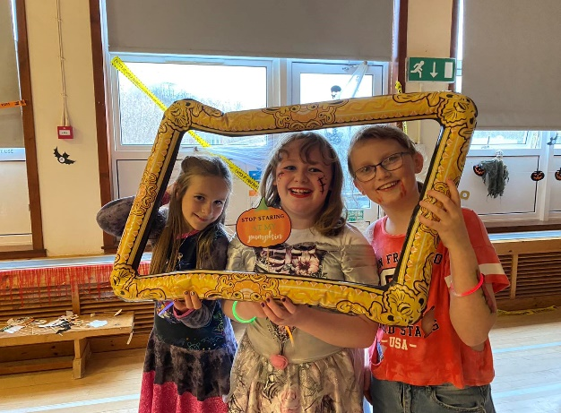*Rousay Sailing Club Skiff Launch Rousay Parent Council’s Halloween disco*

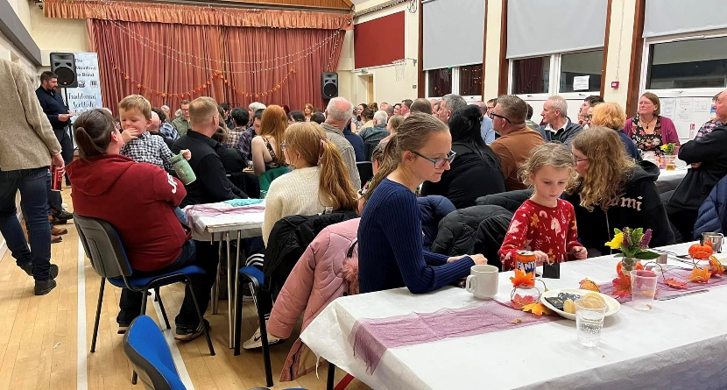 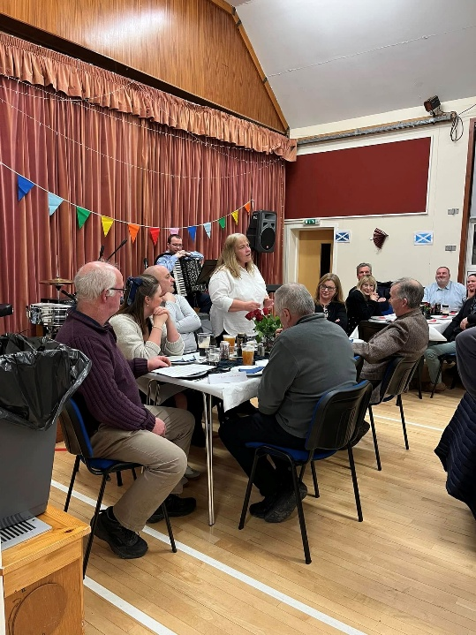

Rousay Community Association’s Harvest Home and Burns’ Supper

**11 General Grants to Community Organisations and Individual Residents**

**Rousay Community Association (£240)**

Funding contribution to broadband installation costs

**Individual Resident (£500)**

Funding contribution for educational school trip

**Taversoe CBS (£20,000)**

Funding CBS set-up costs

**Individual Resident (£225)**

Funding contribution for educational school trip

**Rousay Parent Council (£312)**

Funding contribution to Outdoor Education 2024

**Individual Resident (£750)**

Funding contribution for educational school trip

**Rousay Parent Council (£7,500)**

Funding towards new playpark at Rousay School

**1st Rousay Rainbows & Brownies (£379)**

Funding towards annual subscription fees

**1st Rousay Guides (£274)**

Funding towards annual subscription fees

**Rousay Parent Council (£809)**

Funding towards Outdoor Education 2025 in Hoy

**Rousay Darts Team (£500)**

Funding towards darts tournament transport costs

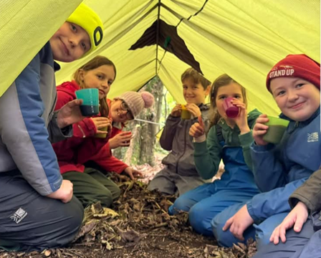 

*Rousay School Outdoor Education Rousay Rainbows & Brownies*

**Grants to Individuals**

**74 Fuel Crisis Grants (£21,300)**

Helping 74 households with electricity costs

**92 Well-being Grants (£18,400)**

Helping 92 residents participate in well-being activities and events

**20 Education & Skills Bursaries (£8,671)**

Enabling residents to enrol on courses that will result in a qualification

**10 Education-related Travel Grants (£1,000)**

Funding travel to educational venues

**5 Medical Support Equipment Grants (£2,120)**

Funding equipment to support medical conditions

**1 Driving Lessons Grant (£750)**

Supporting 1 resident to learn to drive

**2 Emergency Stay Grants (£150)**

Supporting residents when transport is cancelled/delayed, and they are unable to travel home to REW

**‘This grant has helped me get through a long Winter this year. It has helped me to try new activities and get out and speak to people,**

**and I have felt less isolated, which has helped keep my spirits up.’**|

**‘Thank you…The grant will definitely help us during the cold months’**

**‘This grant is an excellent initiative. It’s really helpful to residents.’**

It has been a successful year for our grants scheme and it has been fantastic to see and hear positive community feedback about the grants and the events and activities our grants have supported.

Looking forward to the year ahead, we are excited to hear about your new projects and ideas and how we can help support them throughout this coming year.

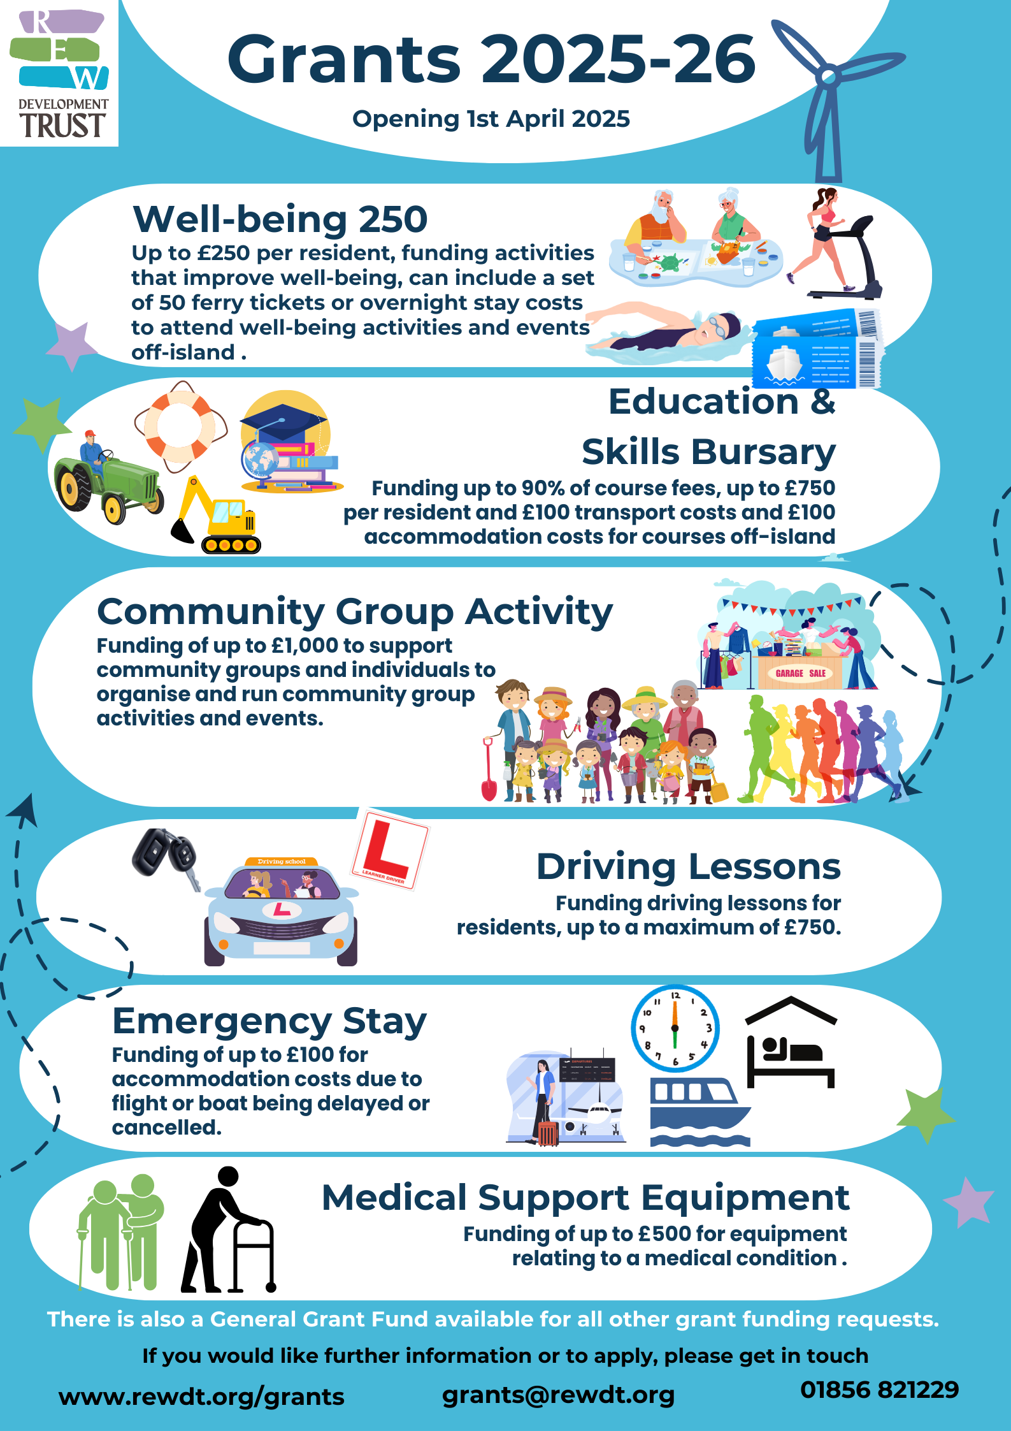

Please remember to submit grant applications for approval before

expenditure is made.